Installation Instructions

Gorilla-Lift® Trailer Tailgate Lift Assist

Model # 40101042GS

WARNING

Tailgate must always be secured and locked when in upright position;
this product is not a substitute for always doing so.

This product does not make the tailgate weight bearing;
the opened tailgate must always rest on firm ground.

Never raise or lower the tailgate while
anyone or anything is under the tailgate.

Keep hands away from all openings,
rollers or cables when product is in use.

CAUTION

Due to the many different sizes, weights and designs of trailers and tailgates on the market today, some minor adjustments may be necessary to ensure your Gorilla-Lift® works properly. Extreme caution must be taken during and after the initial installation of your Gorilla-Lift® to ensure that it is working properly. Always secure and lock your tailgate in upright position before installing, adjusting or working on the Gorilla-Lift®. Check to make sure there is not too much or too little lifting-power on your tailgate. Never force the tailgate up or down: it should travel with very little effort in both directions. Always make sure that the rollers are turning freely, and that the cable is in good condition and travels in the grooved portion of the rollers as it operates.

If you have any trouble with installation, are missing any parts or have any other questions,
please call our customer service department at 1.877.388.8895 or visit our website at www.Gorilla-Lift.com.

Please do not return to or call the store where you purchased the product; we are much better able to assist you.

Parts & Hardware List !! Hardware packs are located inside the housings !!

Imperial Equivalent Quantity True Metric Sizes of Hardware

- housing with an angle cut on one end 2
- housing with square cuts on both ends 2
- 5/16-inch x 2 1/2-inch mounting bolt 8 M8 x 64mm
- 5/16-inch flat washer 8 M8
- 5/16-inch flanged lock nut 8 M8
- spring/cable assembly 2
- 1/2-inch clevis pin 2 13mm
- 1/2-inch locking ring 2 13mm
- grooved roller 4
- 1/4-inch clevis pin 4 6mm
- 1/4-inch flat washer 8 M6
- 1/4-inch locking ring 4 6mm
- 1/2-inch x 5 1/2-inch gate attachment bolt 2 M12 x 140mm
- 1/2-inch flanged lock nut 4 M12
- 1/2-inch flat washer 8 M12
- S-Hook (For installation purposes only!) 2

Tools Required

- Measuring Tape
- Marker and Punch
- Heavy Duty Power Drill
- 1/2-inch Metal Drill Bit
- 2 Adjustable Wrenches
- Needle Nose Pliers
!! Tailgate must always be secured and locked when in upright position !!

IMPORTANT: If the top of your trailer’s side rail is made of round tubing larger than 2-inches in diameter, you will either need longer mounting bolts before beginning installation or you can spot-weld the Gorilla-Lift® on the side rails instead of using mounting bolts. When mounting make sure your housings are straight, level and flush.

Step 1, Attaching to the top of the trailer’s side rails:

- Begin with the driver side of the trailer.
- Place and align housing A (angled & square end with website sticker) & housing B (square ends with Gorilla-Lift® sticker) on top of the trailer’s side rail. Square and align the bottom edge of housing A’s angled end 1/4-inch back from the rear edge of the trailer’s side rail. Make sure that the stickers are lined up on the same side and facing to the outside of the trailer; that the housings are straight and level on rail and flush against each other; and that you are working on the driver side of the trailer.
- Remove housing A from the side rail without disturbing the placement of housing B. Mark the center of housing B’s mounting holes. Replace housing A onto your side rail without disturbing the placement of housing B. Remove housing B without disturbing the placement of housing A. Mark the center of housing A’s mounting holes. Drill 1/2-inch holes (which are oversized) down through the side rail where you made your marks.
- Insert the 5/16-inch x 2 1/2-inch mounting bolts through the mounting holes at the ends of housings A & B where they come together. Place the housings back on the rail, while guiding the 5/16-inch x 2 1/2-inch mounting bolts through the appropriate 1/2-inch holes you just drilled into the side rail. You must make sure that the mounting bolts are seated all the way down into their square holes and that they remain seated when connecting and tightening to the side rail; the oversized 1/2-inch holes that you drilled will allow you to do this. If you do not follow this step, springs will catch on the bolts not allowing the tailgate to go all the way to ground and damage will occur to the springs.
- Make sure that housings A & B are straight, even and tight against each other and that the stickers are still aligned on the same side and facing to the outside of the trailer.
- Insert the 5/16-inch x 2 1/2-inch mounting bolts through the mounting holes on the other ends of housings A & B and through the 1/2-inch holes you just drilled into your side rails. Then, put on and securely tighten the 5/16-inch flat washers and 5/16-inch flanged lock nuts, in that order, to all the mounting bolts. Again, make sure that housings A & B are straight, even and tight against each other and the mounting bolts are seated all the way down into their square holes before securely tightening all the mounting bolts.
- We recommend putting a very thin bead of clear silicone caulk where housings A & B connect.
- Repeat #2 through #7 to mount the Gorilla-Lift® housings on the trailer’s other side rail.

STEP 2, INSTALLING THE SPRING/CABLE ASSEMBLIES:
See figure 1 and figure 3 on page 6.

- Slide a spring/cable assembly into housings A & B, so that the springs are at the end of housing B and the cable is coming out housing A’s angled end.
- Insert a 1/2-inch clevis pin into the rear hole of housing B; then run it through the looped ends of both the inner and outer springs and out the other side of the housing. Be sure you run the pin through the looped ends of both the inner and outer springs. Slide a 1/2-inch flat washer onto the clevis pin; then by using the needle nose pliers and a gentle rocking motion secure the clevis pin in place with a 1/2-inch locking ring. Reverse the position of locking ring’s two ends (over/under) to secure in place. See figure 2 on page 6.
- Repeat #1 and #2 to install the other spring/cable assembly.

STEP 3, INSTALLING THE ROLLERS:
See figure 1 and figure 2 on page 6.

- Insert a 1/4-inch clevis pin into the top hole at housing A’s angled end; then run it through a roller and out the side of the housing. Make sure the cable is lying under this roller.
- Slide TWO 1/4-inch flat washers (smallest holes) onto the clevis pin; then, using the needle nose pliers, secure the clevis pin in place with a 1/4-inch locking ring. You must use two flat washers on this clevis pin to secure it properly.
- Raise the cable and place a roller under it allowing the cable to rest in the grooves; then insert a 1/4-inch clevis pin into the bottom hole at the angled end of housing A; next run it through the roller that you just positioned and out the other side of the housing.
- Slide TWO 1/4-inch flat washers onto the clevis pin; then, using the needle nose pliers, secure the clevis pin in place with a 1/4-inch locking ring. You must use two flat washers on this clevis pin before inserting locking ring to secure the clevis pin properly in place. Reverse the position of locking ring’s two ends (over/under) to secure in place. See figure 2 on page 6.
- Make sure that both rollers spin freely and that the clevis pins remain stationary. You will want to double check this after the cables are attached to the tailgate and you are operating the Gorilla-Lift®.
- Repeat #1 through #5 to install the rollers on the other side.

STEP 4, ATTACHING THE CABLES TO THE TRAILER’S TAILGATE
See figure 4, figure 5 and figure 6 on page 6.

IMPORTANT: After attaching Gorilla-Lift® to tailgate, NEVER FORCE THE TAILGATE IN EITHER DIRECTION!!! If your tailgate won’t go down, one of your springs is catching on a carriage bolt that is not completely seated in housing. If tailgate is forced up or down, your springs will uncoil.

- Secure and lock your tailgate in upright position.
- Attach an S-Hook to looped end of each cable. Raise cables just enough to take the slack out of each and (using the S-Hooks) attach each of them to the mesh on both sides of the tailgate doing so as close to the outer side support angles/tube as possible. See figure 4 on page 6. (S-Hooks are for installation purposes only; NOT for permanent use!)
- SLOWLY lower tailgate halfway down to the ground to make sure the springs are moving freely. Tailgate should balance out in this position and then travel up and down with very little effort. If not, return tailgate to upright position, secure it there and make adjustment A or B:
  - If there is not enough lifting-power on the tailgate, raise the attachment points using the S-Hooks on both sides of tailgate (keeping both attachment points the same height) until the tailgate balances out at almost any position and travels up and down with very little effort.
  - If there is too much lifting power on the tailgate and it will not go completely down or stay completely down, please refer to TROUBLESHOOTING #4.
- Using a marker or punch make a mark on the tailgate side support tube/angle at the same height as the opening in cable loop.
- Drill a 1/2-inch hole through the gate’s side support angle/tube, where you made your mark.
- Slide a 1/2-inch flat washer onto a 1/2-inch x 5 1/2-inch gate attachment bolt.
- Slide the cable thimble onto the 1/2-inch x 5 1/2-inch gate attachment bolt.
- Put a 1/2-inch flanged locking nut, smooth end first, onto the 1/2-inch x 5 1/2-inch gate attachment bolt and tighten the nut to the end of the threads (you might have to adjust this nut’s location on gate attachment bolt back slightly in order for the cable to pull as straight as possible). Then put a 1/2-inch flat washer onto the bolt.
- Two people may be necessary for #9 and #10 if there is significant tension on the cables. Insert the gate attachment bolt into the hole that you just drilled through the tailgate’s side support angle/tube.
- Slide the other 1/2-inch flat washer onto the bolt. Then put on the other 1/2-inch flanged lock nut, flanged side first, and tighten securely to the gate. The flanged locking side of the two nuts should now be in contact with the two flat washers, sandwiching your tailgate’s side support angle/tube between them.
- Repeat #5 through #10 on the other side of your tailgate.

The Gorilla-Lift® should now hold most standard tailgates weightless and balanced at most positions and travel up and down with very little effort. If it does not, you need to increase or decrease the lifting-power by raising or lowering the attachment points on your tailgate or selecting different spring combinations; see TROUBLESHOOTING #4. Never force the tailgate in either direction!

TROUBLESHOOTING:

1) If you are having trouble putting the locking rings on the clevis pins:

- Be sure you are using needle nose pliers, and as you push the ring on the pin gently rock it back and forth.

2) If a roller is not spinning freely:

- Check to see if the angled ends of your housing were bent during shipping; these ends must be straight. Check to see if any burrs or rough spots were overlooked on inside of housing during manufacturing and smooth them down.

3) If your tailgate and/or equipment are rubbing against or hitting the locking rings and clevis pins:

- Change the direction of your pins to where the locking rings are on the opposite side of the housing.

4) If there is too much lifting power on your tailgate follow steps A, B and C in order:

IMPORTANT: Never hook up small inner springs by themselves without first cutting out large outer springs. Doing so can result in damage to large outer springs.

- Disconnect small inner springs and using only large outer springs reattach both cables to tailgate. Use S-Hooks to test different cable attachment positions and lifting power.

IF THERE IS STILL TOO MUCH LIFTING POWER, PROCEED DIRECTLY TO STEP B.

If this corrected your problem, secure and lock tailgate in upright position. Use a heavy-duty wire cutter or a bolt cutter to cut and remove small inner springs from cables leaving only large outer springs connected. Return to “STEP 4, ATTACHING THE CABLES TO THE TRAILER’S TAILGATE.”

- Disconnect both sides and then reattach driver side to tailgate using both the large outer and small inner springs. Use S-Hooks to test different cable attachment positions and lifting power.

IF THERE IS STILL TOO MUCH LIFTING POWER, PROCEED DIRECTLY TO STEP C.

If this corrected your problem, secure and lock tailgate in upright position. Use a heavy-duty wire cutter or a bolt cutter to cut and remove a small inner spring from one cable and a large outer spring from other cable. Return to “STEP 4, ATTACHING THE CABLES TO THE TRAILER’S TAILGATE.”

- Disconnect driver side and then reattach it to tailgate using only large outer spring. Please note, one large outer spring has the same pulling power as two small inner springs. Use S-Hooks to test different cable attachment positions and lifting power.

IF THIS DID NOT CORRECT YOUR PROBLEM, PLEASE EMAIL SUPPORT@GORILLA-LIFT.COM FOR TECHNICAL ASSISTANCE.

If this corrected your problem, secure and lock tailgate in upright position. Use a heavy-duty wire cutter or a bolt cutter to cut and remove large outer springs from both cables leaving only small springs attached. Return to “STEP 4, ATTACHING THE CABLES TO THE TRAILER’S TAILGATE.”

5) If you cannot mount the housings 1/4-inch back from end of side rails:

- You can move them slightly further back, but cables cannot rub against end of side rails when lowering the tailgate all the way down to the ground. This will cause them to fray and eventually break.

- We now sell Extension Roller Assemblies that allow the Gorilla-Lift® to be mounted 3 to 6 inches back from the edge of your side rails. Please visit www.Gorilla-Lift.com for more information.

6) If you have an enclosed trailer or trailer with a dove tail, please email SUPPORT@GORILLA-LIFT.COM for technical assistance.

REQUIRED INITIAL AND MONTHLY INSPECTIONS:

- Make sure that the cables are pulling out of the housings and through the rollers in a straight line; that they are traveling in the grooved portion of the rollers; and that they are not contacting the steel housing or any other obstacle as they operate.
- Inspect the cables for any sign of damage or fraying. Replace the spring/cable assemblies if either of these conditions exist.
- Make sure that all the bolts and hardware are tight, secure and in good condition; this includes the roller pins, which should be tight and not allowed to turn in their holes, only the rollers should turn.
- Make sure that the housings are straight and aligned tightly against each other.
- Make sure that the rollers are in good condition and spinning freely. If the rollers are not spinning freely, clean them inside and out by wiping them with a clean rag. If this does not correct the problem, check and see if there are metal burrs or slivers inside the housing that the rollers could be catching on and file them down smooth.
Never use chemical cleaners or alcohol to clean the rollers; this will damage them.
Do not lubricate the rollers; this will damage them. They are made of a self-lubricating material.
Replace worn rollers. If you do not, your cable will fray and possibly break.

ADDITIONAL REQUIRED INSPECTIONS

After the first two years of service and then every 6 months thereafter, remove the spring/cable assembly from the housing and check for cracks or excessive wear and tear on them. Replace the spring/cable assembly, if either of these conditions exists.

Only use genuine Gorilla-Lift® replacement parts.
Please call 1.877.388.8895 or visit www.Gorilla-Lift.com to order.

FIGURE 1, housing and roller assembly FIGURE 2, locking ring assembly
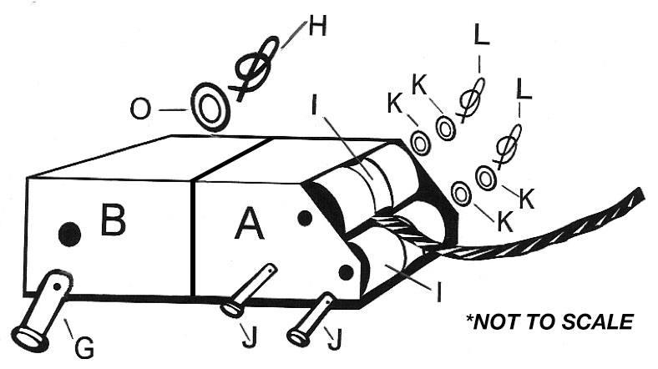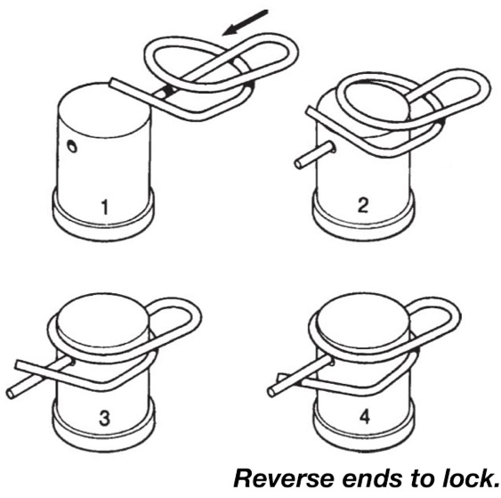

FIGURE 3, spring/cable assembly FIGURE 4, using S-Hook to locate attachment point

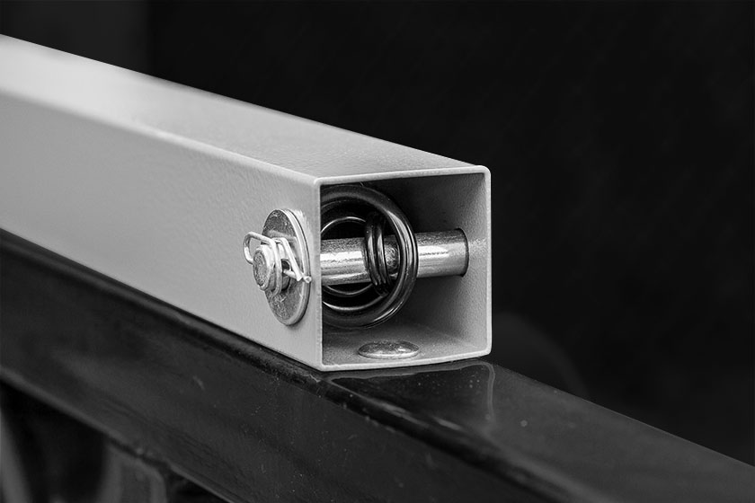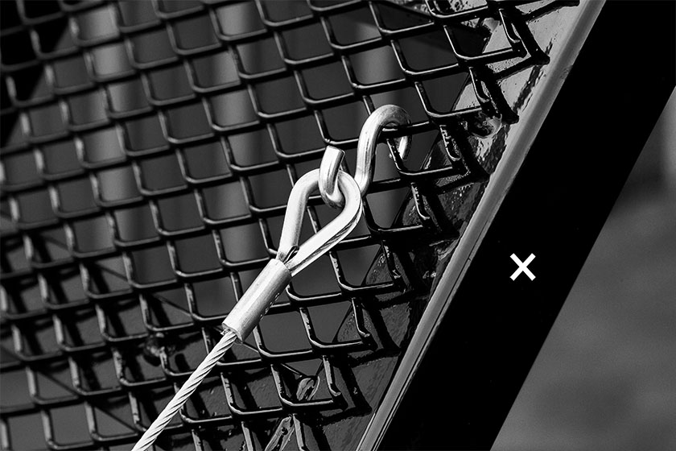

FIGURE 5, gate attachment assembly FIGURE 6, gate attachment

